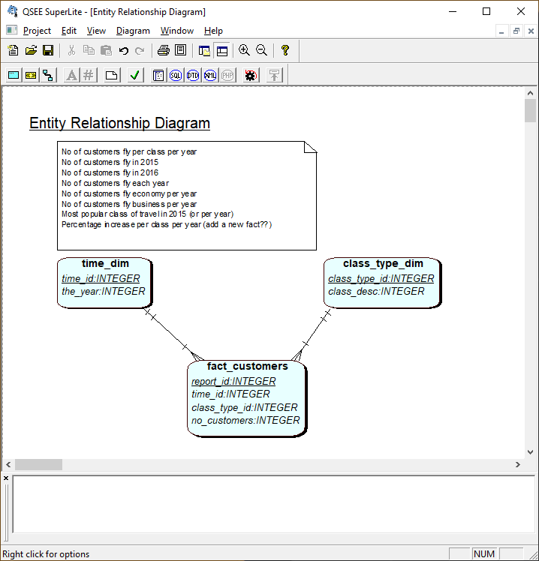

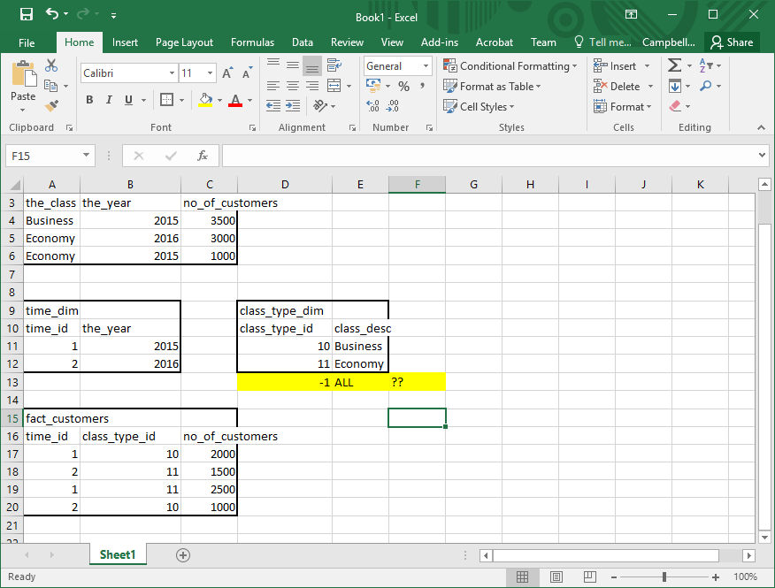

Now forward engineer in QSEE

Check Fks added as you want, include DROP commands, change data types

Load to apex and run

--------------------------------------------------------------

-- Database creation Script

-- Auto-Generated by QSEE-SuperLite (c) 2001-2004 QSEE-Technologies Ltd.

-- Verbose generation: ON

-- note: spaces within table/column names have been replaced by underscores (_)

-- Target DB: SQL2

-- Entity Model :Entity Relationship Diagram

-- To drop the tables generated by this script run -

-- 'C:\Users\campbe10\Desktop\SS1_SQL_drop.sql'

--------------------------------------------------------------

DROP TABLE fact_customers CASCADE CONSTRAINTS;

--------------------------------------------------------------

-- Table Creation --

-- Each entity on the model is represented by a table that needs to be created within the Database.

-- Within SQL new tables are created using the CREATE TABLE command.

-- When a table is created its name and its attributes are defined.

-- The values of which are derived from those specified on the model.

-- Certain constraints are sometimes also specified, such as identification of primary keys.

-- Create a Database table to represent the "fact_customers" entity.

CREATE TABLE fact_customers(

report_id INTEGER NOT NULL,

fk1_time_id INTEGER NOT NULL,

fk2_class_type_id INTEGER NOT NULL,

no_customers INTEGER,

-- Specify the PRIMARY KEY constraint for table "fact_customers".

-- This indicates which attribute(s) uniquely identify each row of data.

CONSTRAINT pk_fact_customers PRIMARY KEY (report_id)

);

-- Create a Database table to represent the "class_type_dim" entity.

CREATE TABLE class_type_dim(

class_type_id INTEGER NOT NULL,

class_desc INTEGER,

-- Specify the PRIMARY KEY constraint for table "class_type_dim".

-- This indicates which attribute(s) uniquely identify each row of data.

CONSTRAINT pk_class_type_dim PRIMARY KEY (class_type_id)

);

-- Create a Database table to represent the "time_dim" entity.

CREATE TABLE time_dim(

time_id INTEGER NOT NULL,

the_year INTEGER,

-- Specify the PRIMARY KEY constraint for table "time_dim".

-- This indicates which attribute(s) uniquely identify each row of data.

CONSTRAINT pk_time_dim PRIMARY KEY (time_id)

);

--------------------------------------------------------------

-- Alter Tables to add fk constraints --

-- Now all the tables have been created the ALTER TABLE command is used to define some additional

-- constraints. These typically constrain values of foreign keys to be associated in some way

-- with the primary keys of related tables. Foreign key constraints can actually be specified

-- when each table is created, but doing so can lead to dependency problems within the script

-- i.e. tables may be referenced before they have been created. This method is therefore safer.

-- Alter table to add new constraints required to implement the "fact_customers_time_dim" relationship

-- This constraint ensures that the foreign key of table "fact_customers"

-- correctly references the primary key of table "time_dim"

ALTER TABLE fact_customers ADD CONSTRAINT fk1_fact_customers_to_time_dim FOREIGN KEY(fk1_time_id) REFERENCES time_dim(time_id) ON DELETE RESTRICT ON UPDATE RESTRICT;

-- Alter table to add new constraints required to implement the "fact_customers_class_type_dim" relationship

-- This constraint ensures that the foreign key of table "fact_customers"

-- correctly references the primary key of table "class_type_dim"

ALTER TABLE fact_customers ADD CONSTRAINT fk2_fact_dim FOREIGN KEY(fk2_class_type_id) REFERENCES class_type_dim(class_type_id) ON DELETE RESTRICT ON UPDATE RESTRICT;

--------------------------------------------------------------

-- End of DDL file auto-generation

--------------------------------------------------------------